The template below contains examples of the main points the information sheet should include. Instructions are italicised, procedure-specific and example wording isn’t. Remember to delete the advisory text and change the footer to be specific to your study.

***Please tailor the information sheet to the participant group (e.g. literacy level) and simplify further if needed***

[Study Title – this may need to be a shorter, lay version]

Information sheet for STUDENTS AGED 11 to 15 years

Central University Research Ethics Committee Approval Reference: [Insert]

We are inviting you to join in a research study. Our names are xxx and we work at the University of Oxford in the Department/Faculty of xxx.
Before you decide if you would like to join in, it’s important to understand what the research is about, why we’re doing it and what it would involve for you. Please read and think about this leaflet carefully. Please feel free to talk to your family, friends, or the researchers about it if you want.
If anything isn’t clear or you have more questions you can ask your parent/guardian to give us a call and we can discuss it with you and your parent/guardian.

Why are we doing this research?
State the background, purpose and aims of the research. Remember to be brief and don’t use overly complicated language that a lay person wouldn’t understand. Consider what a potential participant would want to know.

Why have I been invited to take part?
Explain how they have been identified as a potential participant and mention any inclusion or exclusion criteria, including age range. You should say how many other participants will be recruited.

Do I have to take part?
It is important that participants understand that they have a choice about whether they take part. For example, you could say:
No - It is up to you to decide if you want to take part in this research. You are free to stop taking part at any time during the research without giving a reason by telling your teacher, the researcher or your parent/guardian. You do not have to say why and this will not affect your education.
If you decide to stop, no one will be upset with you.
If you do not wish to join in, you will attend a different class/be seated where you cannot be observed/recorded. [delete as appropriate, or enter alternate provision]

What will happen if I take part in the research?
This section should be written in clear, simple language and include:
- how long the young person will be involved in the research;
- how often they will need to attend visits, meet a researcher, complete questionnaires etc;
- where and how long these visits/tasks will be;
- What the students are being asked to do (e.g. access to personal information, questionnaire, interview, tasks, video/audio recording etc.);
- How consent will be taken;
- It should be made clear what the young person’s responsibilities are during the research, especially if they have to do anything at home e.g. questionnaires / diaries;
- Use the most appropriate format (tables, diagrams, photos etc.). The detail required will depend on the complexity of the research. It may help if the information is displayed in a simple flowchart or grid indicating what will happen at each visit rather than lengthy lists in the text;
- Long-term monitoring/follow-up should be mentioned (if applicable)

What are the possible disadvantages and risks in taking part?
Any reasonably foreseeable discomforts, disadvantages and risks need to be stated. Explain how these risks will be addressed. It is important that young people understand how identifiable they will be from the data and from the research outputs.

Are there any benefits in taking part?
Any benefits to the participants that can reasonably be expected should be stated. However, where there is no intended benefit to the participant from taking part in the research this should be explained. It is important not to exaggerate the possible benefits to the particular participant during the course of the research, this could be seen as coercive. Note that reimbursement should be mentioned in the following section rather than here.
For example you could say: While there are no immediate benefits to you in participating, it is hoped that this research will lead to…
Or There will be no direct or personal benefit to you from taking part in this research.

What information will be collected and what happens to the results of the research?
Results are kept strictly confidential, and only the people doing the research, or helping with the research, can look at the data. Only a number will be used to identify you, and all information and results are kept in [add secure location, e.g. a locked filing cabinet/password-protected computer] in the University. If your face or voice is accidentally recorded, we will make sure that recordings are securely stored (ideally encrypted) and only shared with the rest of the research team. Researchers will change the names of your school, teacher, and all the students when we write about the research. No one will know that you have taken part unless you tell them yourself.
The findings from the research will/may be written up [please describe - e.g. in a thesis, dissertation, academic publications, conference presentations, a report commissioned by an external organisation, websites, videos etc.] Explain whether it will be possible for participants to be identifiable from the outputs and clarify whether they have a choice about this.
If we want to use the information for anything else, we will ask your permission. At the end of the research, we will write to your school about what was discovered. You are welcome to read this if you are interested.
All research data and records will be stored for 3 years after publication or public release of the work of the research. Third parties may be given access to research data for monitoring and/or audit of the research, or for data storage purposes.

Data Protection
The University of Oxford is the data controller with respect to your personal data, and as such will determine how your personal data is used in the research.
The University will process your personal data for the purpose of the research outlined above. Research is a task that we perform in the public interest.
Further information about your rights with respect to your personal data is available from https://compliance.web.ox.ac.uk/individual-rights.

Will anyone else know I'm doing this?
We will keep your information private. This means we will only tell those who have a need or right to know, such as the research team and your parent/guardian. We will only share information that has your name and address removed.

What if I don’t want to take part in the research anymore?
Just tell your parent/guardian and the people carrying out the research that you don’t want to take part. You don’t have to give a reason and no one will be annoyed with you. It is YOUR choice.

Who is organising and funding the research?
Give details of the organiser (named researcher at Oxford University) and funder.

Who has reviewed the research?
This research has received ethics approval from a subcommittee of the University of Oxford Central University Research Ethics Committee. (Ethics reference: xxxxx).

What do I do now?
Please tell your parents, guardians and/or teacher whether you are happy to take part.

What if there is a problem or something goes wrong?
Please tell us if you are worried about any part of this research, by contacting the researcher [insert email]. You may also talk to your teacher/parent/guardian who will let the researcher know. If you are still unhappy or wish to make a complaint, either you or your teacher/parent/guardian can contact

For applications reviewed by
- Medical Sciences Interdivisional Research Ethics Committee
- Social Sciences and Humanities Interdivisional Research Ethics Committee, or
- Departmental Research Ethics Committee
please insert:
the University of Oxford Research Governance, Ethics & Assurance (RGEA) team at rgea.complaints@admin.ox.ac.uk or on 01865 616480.

For applications reviewed by the Oxford Tropical Research Ethics Committee (OxTREC), please insert the contact details for the local ethics committee which has reviewed your research.

Further Information and Contact Details
You should give the participant a contact point for further information. This can be your name, address and telephone number or that of another researcher in the team. If this is a supervised-student project, the student and supervisor should discuss whether to include the student’s contact details as well as those of the student’s supervisor. The use of personal phone numbers should be avoided. Email addresses should be provided by the University (ending in ox.ac.uk).
If you would like to discuss the research with someone beforehand (or if you have questions afterwards), please contact:
[Insert the name of the primary researcher]
[Insert the name of the Department]
[Insert the postal address]
University tel: [insert number]
University email: [insert address]

Thank you for reading – please ask me any questions.

Appendix – Sample images you may wish to use in your PIS

 | 
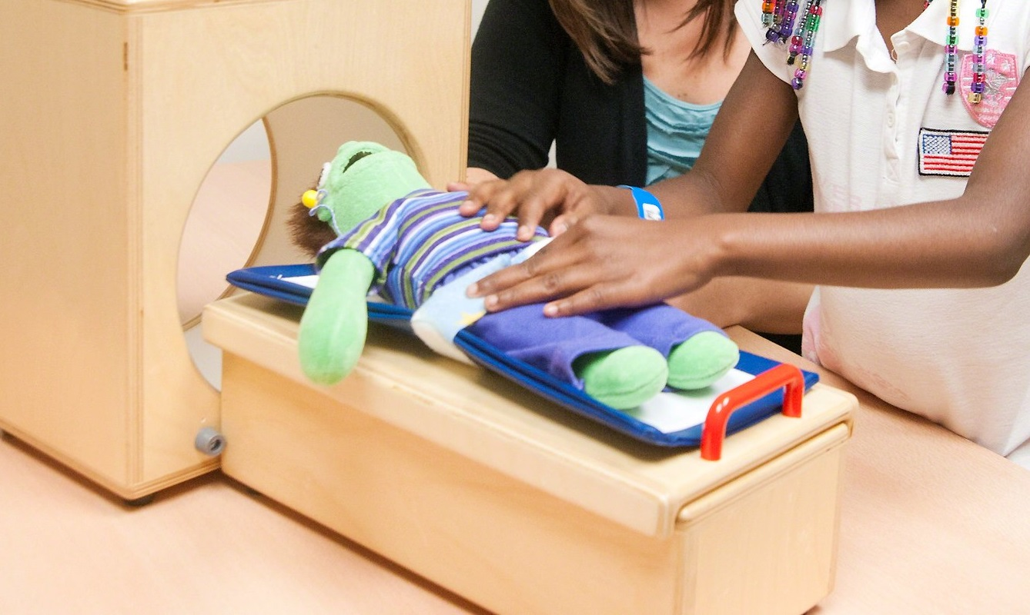 | 

