STUDY TITLE

VOLUNTEERS NEEDED FOR MAGNETIC RESONANCE STUDIES OF THE BRAIN

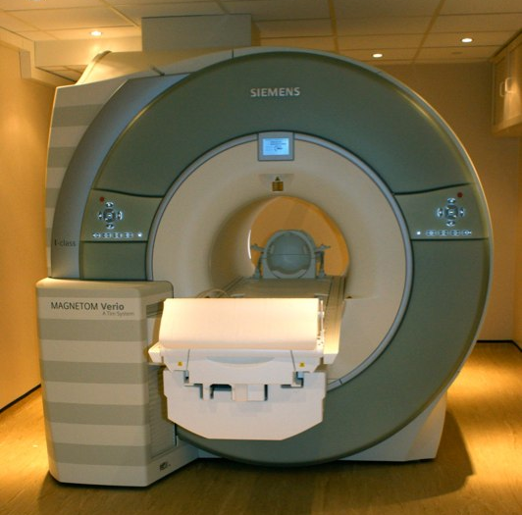

MRI is a type of brain scan that allows us to see how the brain is organised, processes information and performs skills like speech or memory. This scan is safe and does not involve any needles or injections.

We are looking for healthy volunteers to improve our understanding of brain structure and brain function/[study specifics]. The session would take about [study duration] of your time. You would be asked to lie still in a scanner and perform some simple tasks like remembering pictures.

Who are we looking for? Healthy fluent English-speaking men or women aged 18-85 who are not pregnant. You will be asked questions about your medical history to check your suitability for an MRI scan.
If you are interested and would like more information please contact [Principal Investigator] at the [WIN Centre/OCMR, John Radcliffe Hospital, or OHBA, Warneford Hospital] (delete as appropriate), Oxford on [tel] or [email].

Thank you for your time!

Researcher name, contact telephone and email

